# PeopleSafe - Flexible Copay Incentive

Viewing Flexible Copay Incentive Offering in PeopleSafe

Test Claim (Flexible Copay Incentive)

Flexible Copay Incentive on the Plan Benefit Override Screen

Identifying Campaign ID (Prescription Details Screen)

Related Documents

**Description:** Provides procedure and information related to the Flexible Copay Incentive. It is a client specific initiative (offering) which allows clients to offer their plan members a lower or waived copay for choosing a plan specified recommended drug (with their prescriber authorization). Not all clients participate in this program.

|  |
| --- |
| Viewing Flexible Copay Incentive Offering in PeopleSafe |

The offer is also specific to the **drugs**which the client chooses to be included in the Flexible Copay Incentive.

If a client recognizes that many of its members utilize a high-cost brand drug, they may include that drug in the incentive.

* They may choose not to include a drug which their members rarely have filled.
* When a client elects to offer the Flexible Incentive Copay or when a targeted medication has been identified for the member, a letter will be sent informing the member of the incentive and the targeted drug to which it applies. This letter will also be viewable in the **Communication History** tab.
* This program was developed to encourage the member to move to a more cost-effective medication (with their prescriber authorization).
* As a **reward** for moving to a more cost-effective medication the member is given a lower copay or the copay is waived in its entirety.

To verify if a client has elected the Flexible Incentive Copay, access the PeopleSafe Main screen and select the **Client Program Offerings** hyperlink to view the Client program.

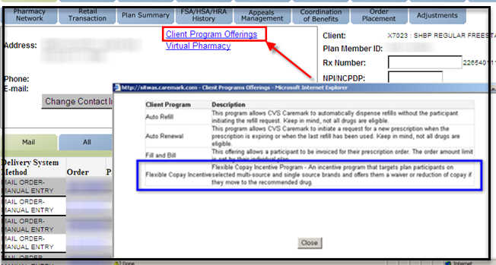

Top of the Document

|  |
| --- |
| Test Claim (Flexible Copay Incentive) |

When the member calls in requesting pricing or requests a refill and questions the difference in cost, run a Test Claim. The Test Claim reveals the Flexible Copay Incentive Settlement Code where the Flexible Copay was used.

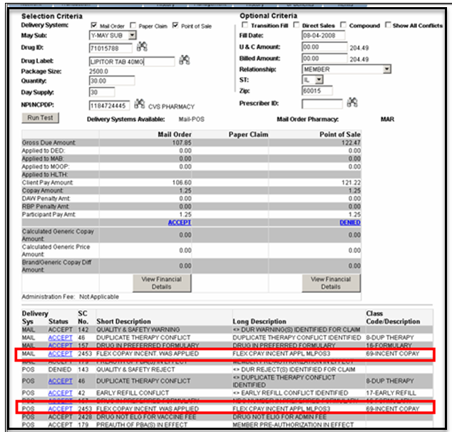

Top of the Document

|  |
| --- |
| Flexible Copay Incentive on the Plan Benefit Override Screen |

When able to view the Flexible Incentive Copay Settlement Code (SC) in the Test Claim, proceed to the **Plan Benefit Override** screen. An override is systematically added to the **Plan Benefit Override** screen and can be identified by the following fields:

|  |  |
| --- | --- |
| **Field** | **Description/Meaning** |
| Class/Code/Description | 69–INCENT COPAY (Override Entered-Benefit available) |
| Comments | Hyperlink to the campaign details revealing what copay incentive is available to the plan member.  **Note: This** hyperlink will be part of the Plan Benefit Override ID. |

**Note: CCRs** that have access to enter PBOs will **not be able to edit** active Flexible Copay Incentive Prior Authorizations (PA). Columns within this screen can be sorted to assist with locating the appropriate PA.

**RxClaim Plan Benefit Override Screen**

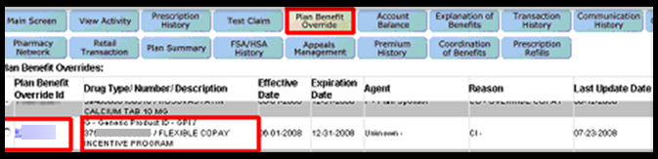

Select the radio button located next to the Pre-Authorization number and select **View Claims** button.

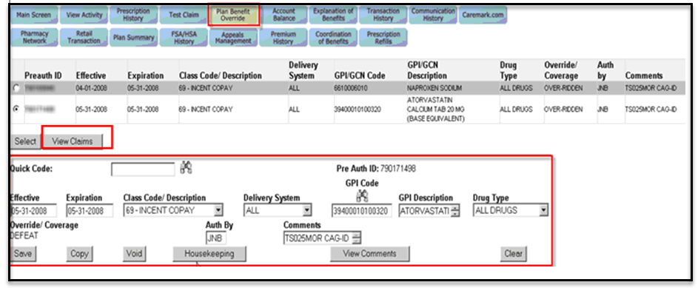

**Result: Reveals** claims which adjudicated against the selected PBO. The **Plan Benefit Override** screen (View Claims Button Pop-Up) displays.

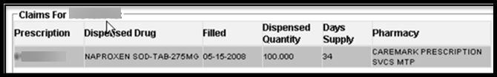

Top of the Document

|  |
| --- |
| Identifying Campaign ID (Prescription Details Screen) |

When the member calls and advises they have received their prescription and the cost is different than what they paid in the past, access the **PeopleSafe Main Screen** and click on the **prescription number**. The **Prescription Details** screen displays click on the hyperlink in the **Campaign ID** (bottom middle of page)field.

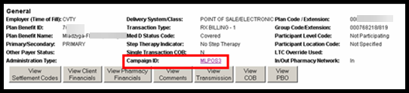

**Result:** A pop-up message displays.

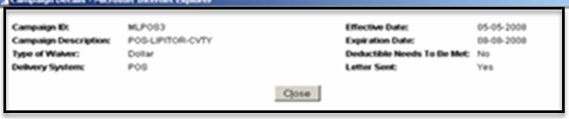

**Tips:**

* Clicking on the **Campaign ID** hyperlink reveals the Campaign Details pop-up.
* Click on the **View Settlement Codes** button (**Prescription Details** Screen) to reveal if the Flexible Copay Incentive override was used.

Top of the Document

|  |
| --- |
| Related Documents |

[Log Activity/Capture Activity Codes (005164)](https://thesource.cvshealth.com/nuxeo/thesource/#!/view?docid=bdac0c67-5fee-47ba-a3aa-aab84900cf78)

[Customer Care Abbreviations, Definitions, and Terms (017428)](https://thesource.cvshealth.com/nuxeo/thesource/#!/view?docid=c1f1028b-e42c-4b4f-a4cf-cc0b42c91606)

**Parent Document:** [CALL 0049 Customer Care Internal and External Call Handling](https://policy.corp.cvscaremark.com/pnp/faces/DocRenderer?documentId=CALL-0049)

Top of the Document

Not to Be Reproduced or Disclosed to Others without Prior Written Approval

**ELECTRONIC DATA = OFFICIAL VERSION / PAPER COPY = INFORMATIONAL ONLY**